NFS (Network File System)

Introduction
Network File System (NFS) is a protocol that enables the sharing of files and directories across systems on a network. It is especially useful for distributing large sets of files among multiple devices efficiently.
Purpose: File sharing over a network
Default Port: 2049

Server Configuration Steps

1. Install NFS Utilities
Install the required NFS package:
- # yum install nfs-utils

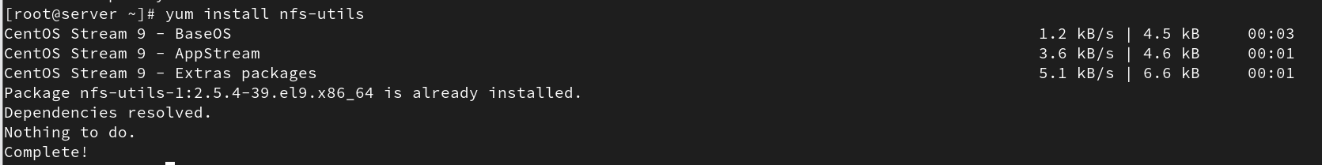

Check the rpcbind service status:
- # systemctl status rpcbind.service

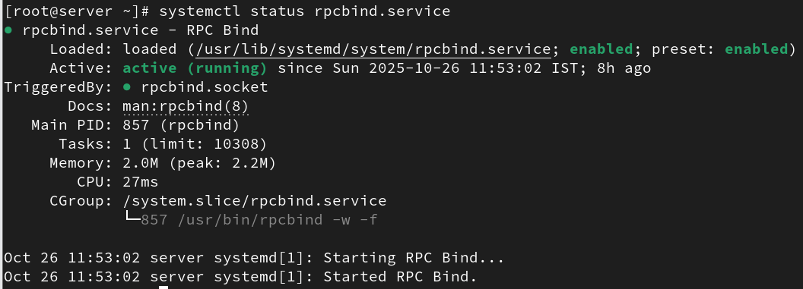

2. Disable SELinux
SELinux (Security-Enhanced Linux) enforces strict access controls that may interfere with NFS operations. To disable it:
- # vi /etc/selinux/config
Change SELINUX=enforcing to SELINUX=disabled
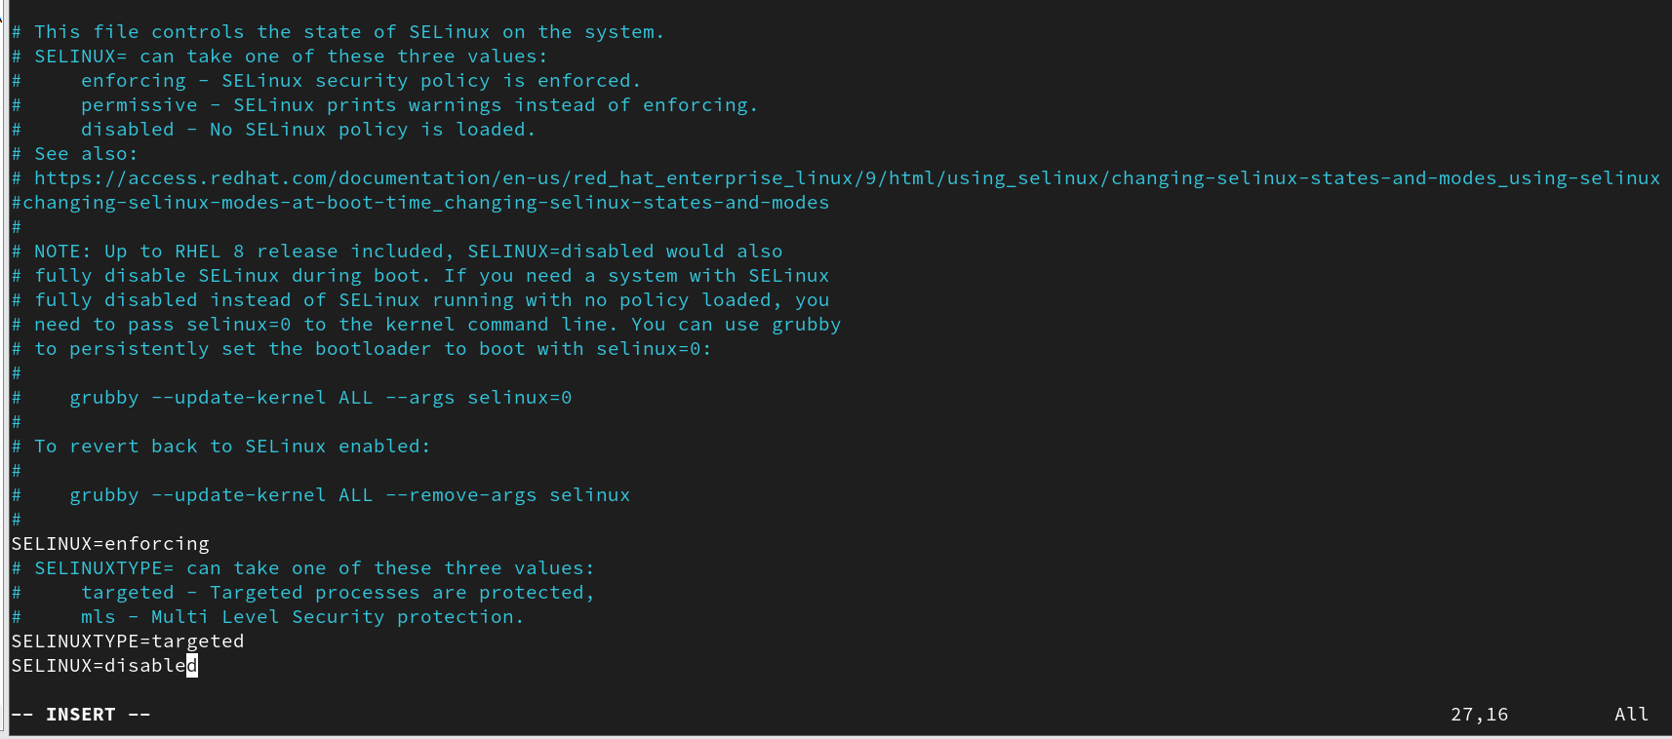
Check the SELinux status:
- # sestatus

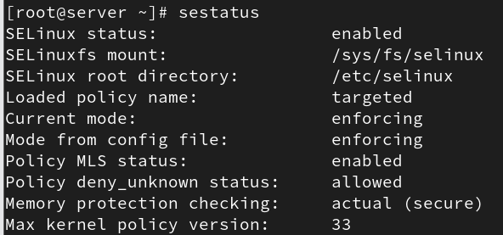

3. Enable the NFS Service
Enable and start the NFS service:
- # systemctl enable --now nfs-server.service

4. Create a Shared Directory
Create the directory to be shared (for example, /sharedata):
- # mkdir /sharedata

5. Configure NFS Exports
Edit the exports configuration file:
- # vi /etc/exports
Add an entry for your client:
- /data client-IP(rw,sync,no_root_squash)

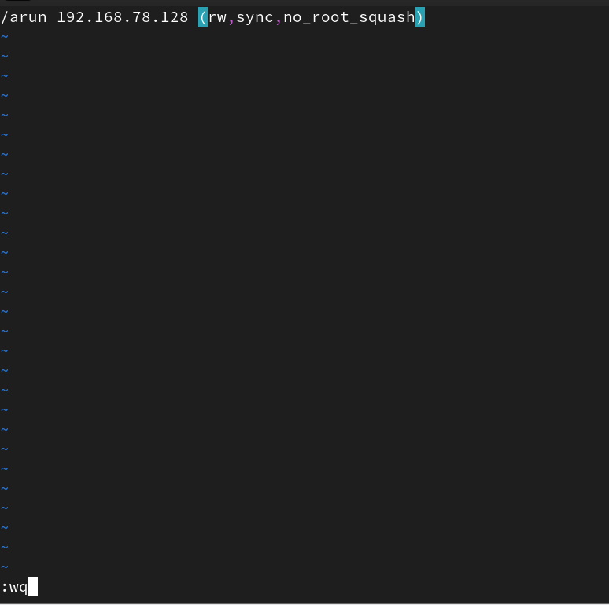

6. Export the Shared Directory
- # exportfs -rav

- # exportfs -v

7. Verify the Export
Check exported directories:
- # showmount -e

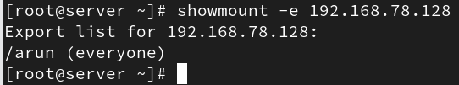

8. Disable Firewall and SELinux Temporarily
To avoid access issues during setup:
- # systemctl disable --now firewalld.service
- # setenforce 0
- # getenforce

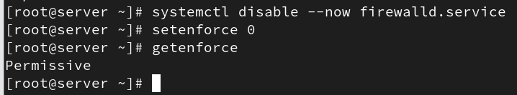

Client Configuration Steps

1. Install NFS Utilities
- # yum install nfs-utils

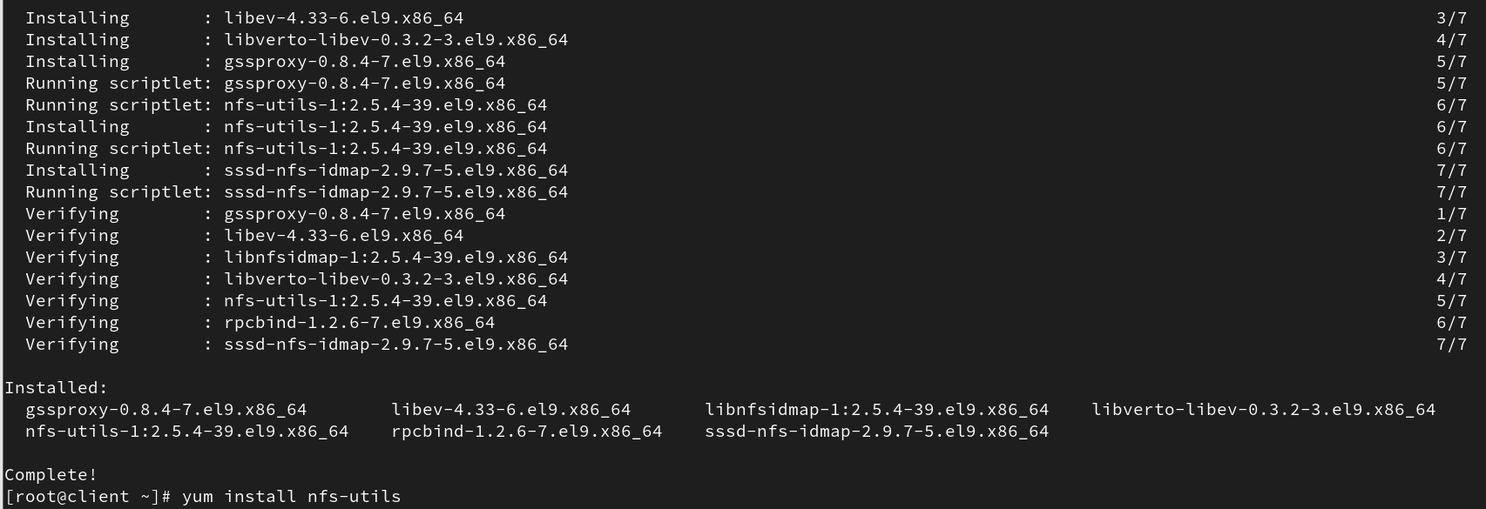

2. Check Available Exports
- # showmount -e server_IP

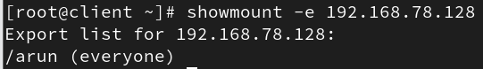

3. Create a Mount Point
- # mkdir /dir_name

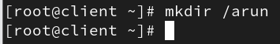

4. Mount the Shared Directory
- # mount server_IP:/dir_name(server) /dir_name(client)

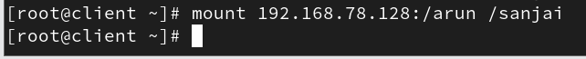

5. Verify Mount
- # df -h

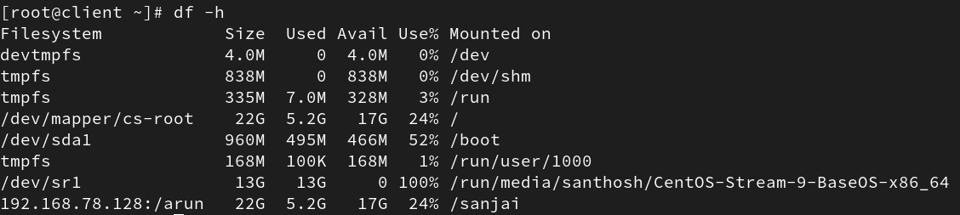

6. Test File Creation
Create a file in the mounted directory and verify that it appears on the server.
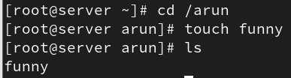

Same file should appear in server
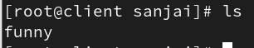

Root Access Options in NFS
Option | Client Root Privileges on Server | Security Risk | Description
root_squash | None (mapped to "nobody") | Low (secure) | Disables root privileges from clients.
no_root_squash | Full root privileges | High (risky) | Grants root access; use only for trusted clients.
root_squash → Safer; prevents remote root access.
no_root_squash → Grants full root permissions; use cautiously.

Testing Behavior
• If no_root_squash is configured, files created on the client will appear on the server.
• If root_squash is set, the client cannot create files on the server’s shared directory.
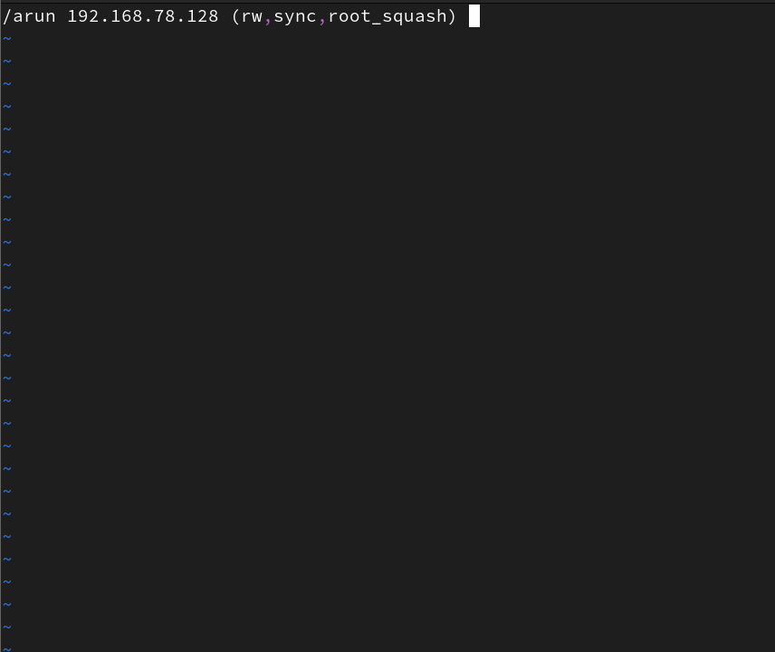
You cant create a file in client mechine
